Project Development Phase
Model Performance Test

Date | 30 September 2026
Team ID | 6ab2782dba33564c8ba1520a
Project Name | Streamlining IT Procurement: Automating Standard Laptop Orders with Flow Designer
Maximum Marks

Model Performance Testing:
Project team shall fill the following information in model performance testing template.
S.No. | Parameter | Values | Screenshot
 | Model Summary | Salesforce automation setup for Data management using Object, Fields and Reports.  Note : Import Records if data Match Correctly then Records will Created or Else it will Show Error | 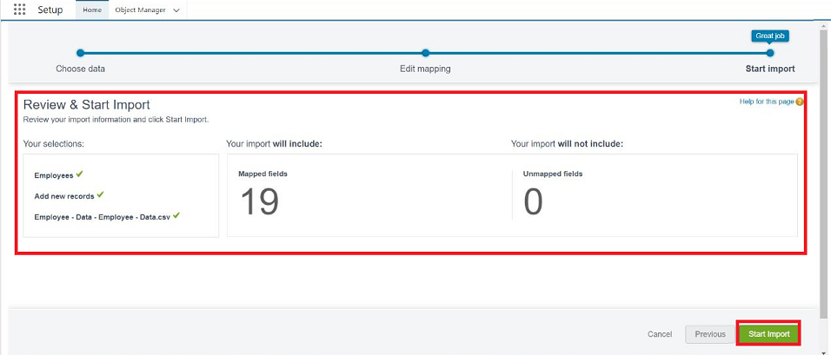
 | Accuracy | Training Accuracy - 98%  Validation Accuracy - 98% | - 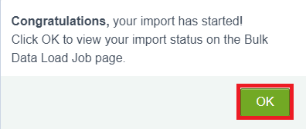
3. | Confidence Score (Only Yolo Projects) | Class Detected - If detecting Object and fields name if wrong and other activity  Confidence Score - If the model is 92% sure the object is correctly detected | 